

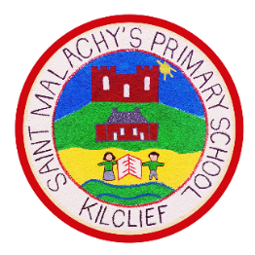Saint Malachy’s Primary School, Kilclief.

8 Kilclief Road, Kilclief, Downpatrick, BT30 7PA

Tel: 02844 881477 [www.stmalachysps.com](http://www.stmalachysps.com)

E-Mail: [info@stmalachyspskilclief.downpatrick.ni.sch.uk](mailto:info@stmalachyspskilclief.downpatrick.ni.sch.uk)

Principal: Mr Ciaran Clifford [cclifford278@c2kni.net](mailto:cclifford278@c2kni.net)

Dear Parents / Guardians,

It is with great excitement and pride that I write this letter of introduction to you as the new Principal of St. Malachy’s Primary School Kilclief.

I am truly honoured to be given this opportunity to be a part of this school and to support the students and families of such a close-knit and welcoming community and look forward to immersing myself completely in our school and in the community. My main responsibility is to support our staff to allow them to succeed, and this in turn will support the pupils of St. Malachy’s in allowing them to achieve their maximum.

During the course of this coming year, it is my hope that we will work together to provide the students in St. Malachy’s the best opportunities in preparing for the world around them, and ready to face and overcome challenges and obstacles that may be placed in their path. As Principal, my door is always open, and I welcome your input to further the school across a range of different areas, and you can reach me at [cclifford278@c2kni.net](mailto:cclifford278@c2kni.net) or via 02844 881477. Please feel free to stop in or call to make an appointment to discuss your concerns, suggestions, or ideas to help make this school the best it can be!

Please pay close attention to any messages on our school’s website and Facebook page for updates on events and achievements within St. Malachy’s.

Kind regards,

Mr Ciaran Clifford